Colour Code Format
- We’d like to know if vertical version’s design is different from horizontal version or not.
- We’d like to know if the reverse side design is different from the front side or not.

 | Design | Section | sRGB | CMYK | Pantone
Front side | Horizontal  Vertical | A
Front side | Horizontal  Vertical | B
Front side | Horizontal  Vertical | C
Front side | Horizontal  Vertical | D
Front side | Horizontal  Vertical | E
Front side | Horizontal  Vertical | F
Front side | Horizontal  Vertical | G
Front side | Horizontal  Vertical | H
Front side | Horizontal  Vertical | I
Reverse side | Horizontal  Vertical | A
Reverse side | Horizontal  Vertical | B
Reverse side | Horizontal  Vertical | C
Reverse side | Horizontal  Vertical | D
Reverse side | Horizontal  Vertical | E
Reverse side | Horizontal  Vertical | F
Reverse side | Horizontal  Vertical | G
Reverse side | Horizontal  Vertical | H
Reverse side | Horizontal  Vertical | I

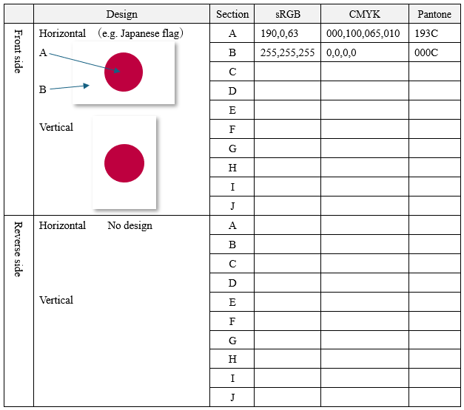
For the Japanese flag, rotate 90 degrees
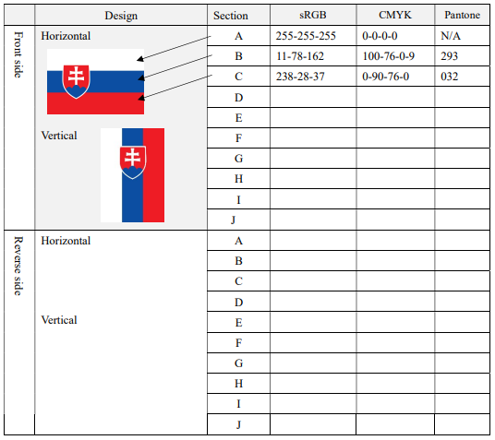
For Slovak flag, rotate 90 degrees to the left but Coat of arms does not rotate


Baton etc.: Vertical Hoist
Pole : Horizontal Hoist
Example

